**Code:**

**#Code1**

**# Python program to illustrate the concept**

**# of threading**

**# importing the threading module**

**import threading**

**def print_cube(num):**

**# function to print cube of given num**

**print("Cube: {}" .format(num * num * num))**

**def print_square(num):**

**# function to print square of given num**

**print("Square: {}" .format(num * num))**

**if __name__ =="__main__":**

**# creating thread**

**t1 = threading.Thread(target=print_square, args=(10,))**

**t2 = threading.Thread(target=print_cube, args=(10,))**

**# starting thread 1**

**t1.start()**

**# starting thread 2**

**t2.start()**

**# wait until thread 1 is completely executed**

**t1.join()**

**# wait until thread 2 is completely executed**

**t2.join()**

**# both threads completely executed**

**print("Done!")**

**#Code2**

**# Python program to illustrate the concept**

**# of threading**

**import threading**

**import os**

**def task1():**

**print("Task 1 assigned to thread: {}".format(threading.current_thread().name))**

**print("ID of process running task 1: {}".format(os.getpid()))**

**def task2():**

**print("Task 2 assigned to thread: {}".format(threading.current_thread().name))**

**print("ID of process running task 2: {}".format(os.getpid()))**

**if __name__ == "__main__":**

**# print ID of current process**

**print("ID of process running main program: {}".format(os.getpid()))**

**# print name of main thread**

**print("Main thread name: {}".format(threading.current_thread().name))**

**# creating threads**

**t1 = threading.Thread(target=task1, name='t1')**

**t2 = threading.Thread(target=task2, name='t2')**

**# starting threads**

**t1.start()**

**t2.start()**

**# wait until all threads finish**

**t1.join()**

**t2.join()**

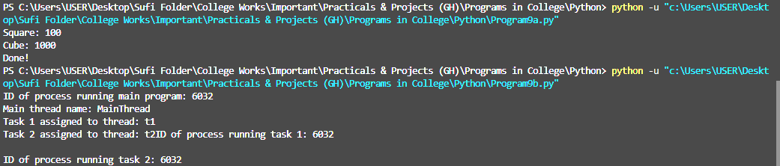**Output:**